LISTENING SCRIPT
TO UN
TAHUN 2015-2016

Listening Section
In this section of the test, you will have the chance to show how well you understand spoken English. There are four parts to this section, with special directions for each part.
Part I
Questions 1 to 4
Directions:
In this part of the test, you will hear some dialogues spoken in English. The dialogue will be spoken twice. They will not be printed in your test book, so you must listen carefully to understand what the speakers are saying.
After you hear a dialogue and the question about it, read the five possible answers and decide which one would be the best answer to the question you have heard. Now listen to a sample question.
You will hear:
Man : Are you free on Saturday morning?
Woman: Yes. Any plan to do?
Man : We’ll see a book fair at JCH. Do you care to join?
Woman: I’d love to.

You will also hear:

Narrator: What are the speakers talking about?
Sample answer
You will read in your test book:
A B C D E

- Loving books
- Asking free time
- Buying some books
- Planning to see book fare
- Activity on Saturday morning

The best answer to the question “What are the speakers talking about?” is choice (D). Therefore, you should answer choice (D)

- Man : Do you know that yesterday one of our friends, Dina won the speech contest?
Woman : Really, I am proud of her.
Man : She deserved it. She practiced a lot.
Woman : Yes, you are right.

Narrator : What are they proud of?

- Dina’s winning the speech contest
- The man’s winning the speech contest
- The woman’s practicing for a speech contest
- Dina’s practicing for a speech contest
- Their practicing for a speech contest

- Woman : Hey. Bob.
Man : Hey , Kayla
Woman : Bob, you look so pale today, what’s the matter?
Man : I have been recovered from ill.
Woman : I am sorry. I don’t know about that.
Narrator : What is the condition of Bob?
- He is sick
- He is healthy
- He is hospitalized
- He is being recovered
- He is being taken care.

- Man : Have you finished typing the annual report we
discussed last week?
Woman : Yes, I’ve done it. You mean this report?
Man : That’s right.
Woman : How do you think about it?
Man : Well done. Congratulations!

Narrator : What are they talking about?

- Report discussion
- Annual discussion
- Weekly report
- Annual report
- Daily report

- Woman : Hey. Bob.
Man : Hey , Kayla
Woman : Bob, you look so pale today, what’s the matter?
Man : I have been recovered from ill.
Woman : I am sorry. I don’t know about that.
Narrator : From the dialog above what is the condition of Bob?
- He is sick
- He is healthy
- He is hospitalized
- He is being recovered
- He is being taken care.

Part II
Questions: 5 to 7
Directions:
In this part of the test, you will hear several questions or statements spoken in English followed by four responses, also spoken in English. The questions and responses will be spoken twice. They will not be printed in your test book, so you must listen carefully to understand what the speakers are saying. You have to choose the best response to each question or statement.
Now listen to a sample question:

You will hear:
Man : You look uncomfortable.
Woman: It’s very hot here.
Woman: I’ll switch on the fan for you.
Man :
Sample answer

A B C D
You will also hear:
- I’ll be glad.
- I’ll be happy.
- Thank you.
- It’ll be okay.

Narrator: What is the best response to the woman’s statement?
The best response to the woman’s statement “I’ll switch on the fan for you.” is ” (Thank you.) Therefore, you should answer Choice “C”.

- Man : We have been waiting for the bus almost an hour.
Woman : Yes, I suppose its’ route has been changed.
Man : As far as I know, it never passes through this road.
Woman : What do you think we should do?
Man : …

Narrator: What would the man probably respond?

- I think we are supposed to change the bus
- Why don’t we should wait for the bus.
- I think, it’s better we take a taxi.
- How about asking the police.

- Man : Why do you look so confused?
Woman : Well, my father wants me to continue to Medical Faculty, my mother
persuades me to join the Navy.
Woman : And what do you want?
Man : I am interested in Literature. So I want to continue to English Departement.
Woman : …

Narrator : What is the man’s response to the man’s statement?

- I hope you can talk it over with your family.
- She persuades the son about his major
- Congratulations for your achievement.
- I think you should have some rest.
.

- Man : Nita, You seem so in hurry.
Woman : Oh, I need to deliver this document to Sudirman Street. But I
have a problem.
Man : Why? You can ask the office driver to take you there.
Woman : He takes Mr. Wong to a meeting. Furthermore, it is rush hour so the
traffic is a nightmare and taxi is really hard to find.
Man : …
Narrator : What is the best response to the woman’s statement?
- I wish you can finish it soon.
- Do you want some refreshment?
- I hope you will get what you want.
- May I order an online taxi for you?

Part III
Questions 8 to 10.
Directions:
In this part of the test, you will hear some monologues spoken in English. The monologues will be spoken twice. They will not be printed in your test book, so you must listen carefully to understand what the speakers are saying.
After you hear the monologue and the questions about it, look at the pictures and decide which one would be the best answer to the question you have heard.
The following monolog is for question number 8.
For the people of West Java, where Gedung Sate is now the headquarters of the Provincial Government of West Java gives pride. The building is in addition to the high historical value also its presence known not only indigenous people but nationally, buildings built since July 27, 1920 This is a historical asset, even internationally also know, given this building was built in the Dutch colonial period. No wonder if the building is located in Bandung is a feature and a symbol of West Java. The skewers were stuck at the top of the building is reinforced characteristic building that is now the center of West Java Provincial Government.
With the shape of a rectangular building, stretches from South to North, Gedung Sate wheelbase straight into the middle of Mount Maras. Originally, this beautiful building called the House Hebe absorbed from the abbreviation BG or Gounverments Bedrijven by residents that time, but later better known as Gedung Sate at the top of the tower building there is a skewer with six ornaments shaped guava.

Which picture goes to the monologue?

A B

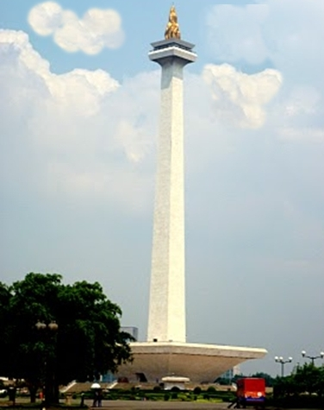 | 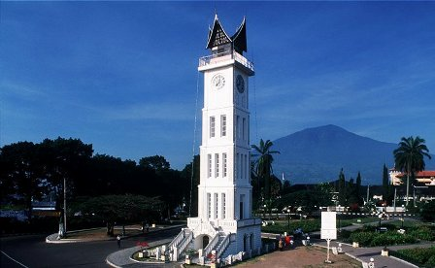
C  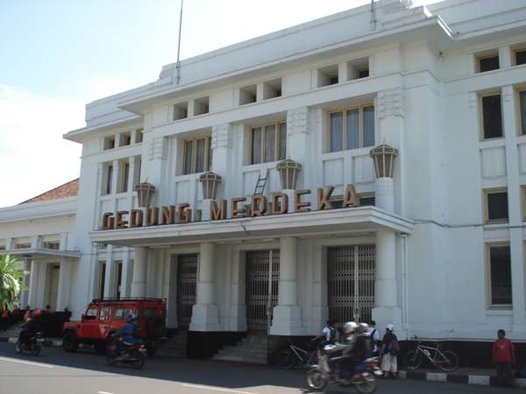 | D  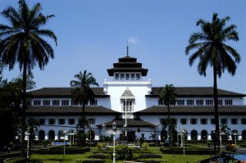
E
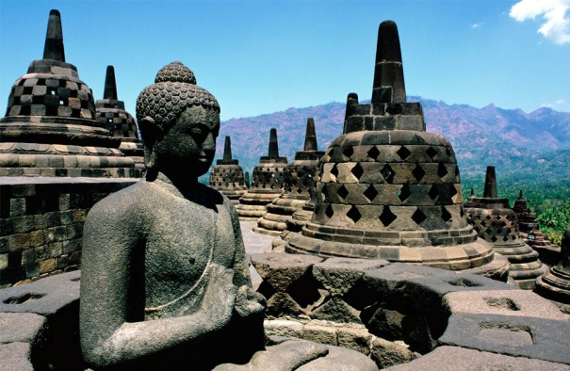

The following monolog is for question number 9

This mechanical device uses a draft of air to remove dust, loose dirt, or other particulate matter from dry surfaces. It is especially useful on highly textured surfaces, such as carpets and upholstery, that are difficult to clean by wiping or brushing. Usually, an electrically powered fan is used to produce a zone in which the air pressure is below atmospheric pressure, causing a draft of air to flow through the material to be cleaned, carrying the small particles with it.

Which picture is suitable with the speaker ‘s description of the object?

A B

C | D
E

The following monolog is for question number 10.
Lenka is small and quite slim. She has got an oval face with bright blue eyes and a small mouth. She has long brown wavy hair. She is quite beautiful, especially when she smiles. She always seems to be in a good mood. We have nearly the same hobbies and sometimes the same opinions. She always brings out the best in me by being positive and cheerful.
She is like a part of my family. I trust her as much as I trust my close family member. I find her very honest; she always says what she thinks. We are really close to each other; she can tell if I'm lying even if I am keeping a straight face! I don't know how she does it!
I don't know how it is possible but I am never bored with her.
A B C D E

The following monolog is for question number 11.
There is one traditional house that interests me very much. This house is made of mostly woods and dried leaves or grass because the people live in a mountainous area . There is no window on the house to protect the inhabitants from the strong cold wind from the mountain. The house is about 2.5 meters high and in the middle of it, there is a piece of land to make fire at night. The male and female live in the separate house. The male house is called Honai and the female one is called Ebei.

Which picture goes to the monologue?

A. | B. 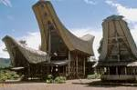 | C. 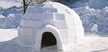 | D.  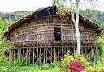 | E.

Part IV
Questions 12 to 15
Directions:
In this part of the test you will hear several monologues. Each monologue will be spoken twice. They will not be printed in your test book, so you must listen carefully to understand what the speakers are saying.
After you hear the monologue and the questions about it, read the five possible answers and decide which one would be the best answer to the questions you have heard.
The following monolog is for questions number 12 and 13.
One day, when Sangkuriang was hunting, he accidentally killed his beautiful black dog Si Tumang. This dog was actually Sangkuriang ‘s father who had been condemned to live the life of dog by his GURU. However, Sangkuriang never knew it.
Sangkuriang had been separated from his mother since childhood. On his way home, he stopped at a small village and fell in love with a beautiful girl. He didn’t realize that the village was his homeland nor that the beautiful girl was his own sacred mother who remained young and pretty.
Their love grew naturally and one day, when they were discussing their wedding plans, Dayang Sumbi suddenly realized that the profile of Sangkuriang’s head matched that of her son’s who had left twenty years earlier. How could she marry with her own son? But she didn’t wish to disappoint him. So she agreed to marry Sangkuriang only on the condition that he would provide a lake and a boat with which they could sail on their wedding day the next day at dawn.
Sangkuriang accepted this condition. He damned up the Citarum river to make a lake. Dayang Sumbi realized that Sangkuriang would fulfill the condition she had set. With a wave of her supernatural shawl, she lit up the eastern horizon with flashes of light. Deceived by false dawn, the cock crowed and farmers rose for the new day.
Sangkuriang realized that he failed to finish the boat. With all his anger, he kicked the unfinished boat upside-down. The boat is now known as the mount Tangkuban Perahu.

- What is the text about?

- Nyi Loro Kidul
- Sangkuriang
- Jaka Tarub
- Bandung Bondowoso
- Tangkuban Perahu

- Where did Sangkuriang meet the beautiful girl?

- At Tangkuban Perahu
- At Citarum River
- At a small village
- At Bandung City
- At Dayang Sumbi’s house
The following monolog is for questions number 14 and 15.
YONKERS, Nov 12th. A four alarm fire damaged 14 stores today in the Cross County Shopping Center. The largest shopping Center in Westchester County.

Two fire investigators said the blaze apparently started in a pile of cardboard cartons at the rear of a shoe store and spread through a utilities duct above the 13 other stores. The fire started at 4.40 p.m. and was declared under control at 6.14 p.m. The center is on the Cross County Parkway at the Gov. Thomas E Dewey Thruway.

Five fire-fighters were busy at the scene; Lieut. John Carey of Yonkers Arson Squad said the cause of the fire was under investigation.

- What are the speakers talking about?

A. The Yonkers Arson Squad.
B. The blaze at the shoe store
C. A fire in the shopping center
D. A shopping center in the cross county.
E. The largest shopping center in Westchester County.

- How many fire fighters were involved in the scene?

A. Four
B. Five
C. Six
D. Seven
E. Eight
THIS IS THE END OF THE LISTENING SECTION

